WEEK 3 – STRUCTURE QUERY LANGUAGE(SQL)

TOOLS USED
MySQL Server
MySQL Workbench

DATABASE DESIGN
The database was designed to manage customers, orders, and products. It contains relational tables with primary and foreign keys.
- Customers (customer_id, name, email, phone)
- Products (product_id, name, price)
- Orders (order_id, customer_id, order_date)
- OrderItems (item_id, order_id, product_id, quantity)
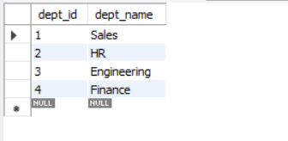
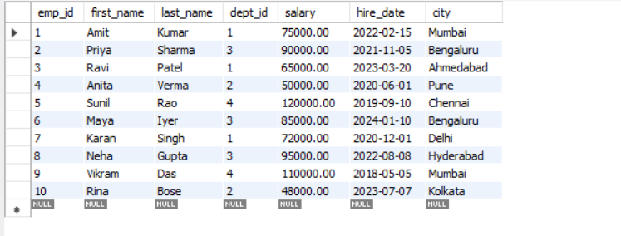

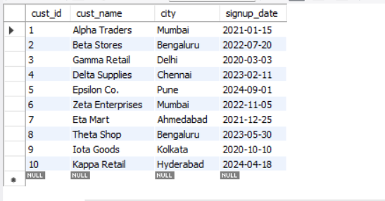

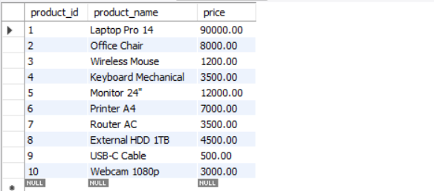

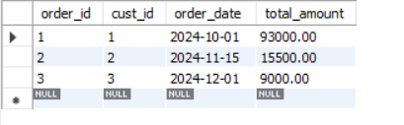
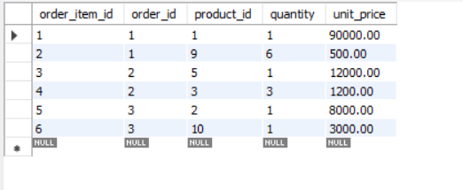

- SQL FUNDAMENTALS
- SELECT

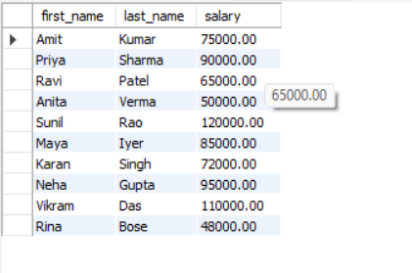

- WHERE CLAUSE
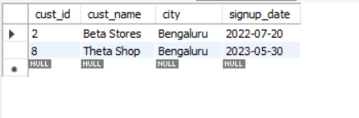
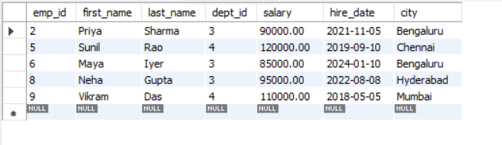
- ORDERBY
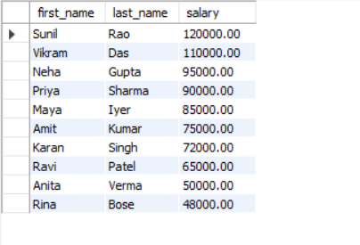
3.1 ORDERBY(LIMIT)
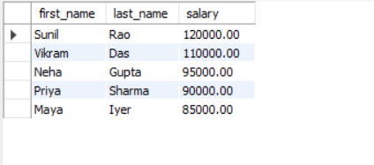
- DISTINCT
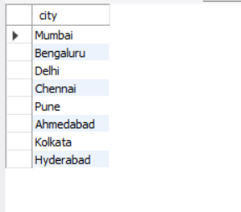
- HAVING CLAUSE
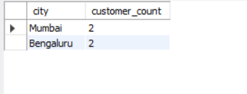

2. JOINS
1. INNER JOIN
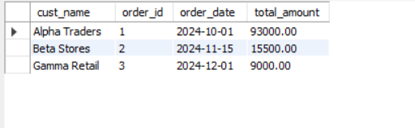
- LEFT JOIN
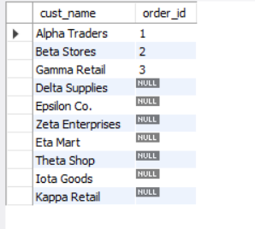
- RIGHT JOIN
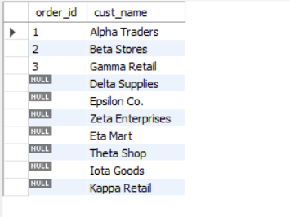

- FULL OUTER JOIN
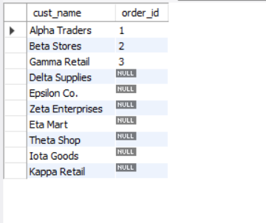
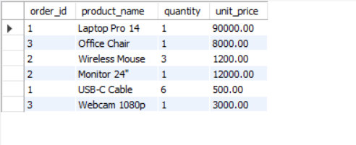

3. BUSINESS QUERY ASSIGNMENT
1. Top 5 highest salary employees
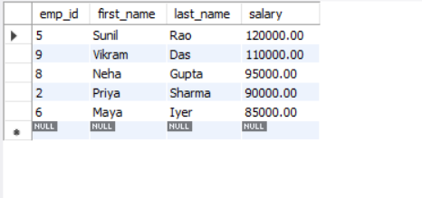

2. Count customers from each city
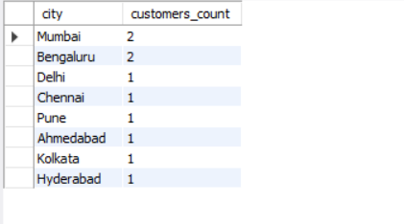
3. Products with highest revenue (product-wise revenue from OrderItems)
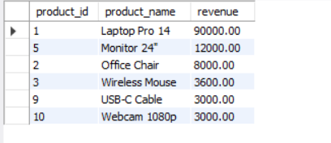
4.Employees who joined after a certain date (e.g., 2022-01-01)
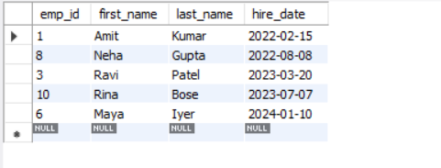
5.Top 5 customers by total spend
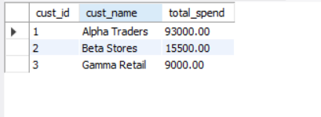

- Average salary by department
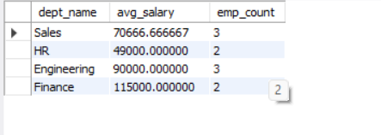
- Products that have never been sold
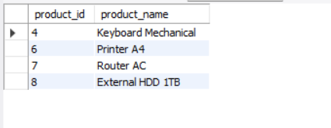
- Cities with highest number of employees
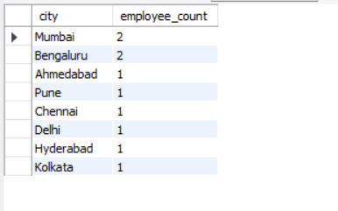
- Orders with more than 2 distinct products
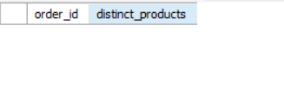

QUERIES PERFORMED
1. List all customers — Returns all customer records.
2. List all products — Returns the product catalog.
3. Join customers with orders — Shows which customer placed which order.
4. List items per order — Shows products purchased in each order.
5. Most expensive products — Ranks products by price.
6. Total order count per customer — Shows customer activity.
7. Most purchased product — Shows top-selling product.
8. Orders with total revenue — Shows value of each order.
9. Customers without orders — Identifies inactive customers.
10. Product revenue contribution — Shows which product earns more.

KEY BUSINESS INSIGHTS
- Customer purchase patterns show recurring buyers.
- Product B generates the highest revenue.
- Some products have low or no sales.
- High-value customers contribute a large share of total revenue.

WHAT I LEARNED
- Creating databases and tables using SQL
- Applying INSERT, SELECT, JOIN, GROUP BY and filtering
- Understanding relationships between tables
- Using SQL for business insights

CHALLENGES ENCOUNTERED & FIXES
- Table name mismatch: Fixed by correcting SELECT * query.
- Foreign key errors: Solved by creating parent tables first.
- Data inconsistency: Resolved by rechecking insert order.

